A247 Afr-Egy-Ushabti-New Kingdom-19-20th Dynasties-1292–1069 BCE-**Hieroglyphs-**Winged Scarab-Pectoral-Faience

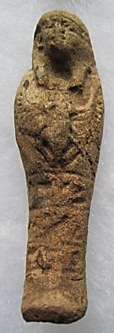 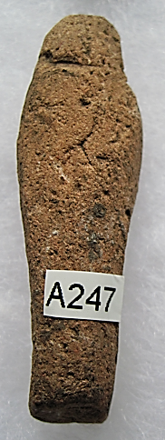 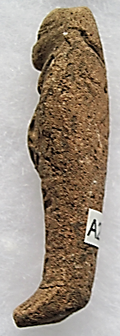

Figs. 1-2. Ushabti-New Kingdom-19-20th Dynasties-1292–1069 BCE-**Hieroglyphs-**Winged Scarab-Pectoral-Faience

**Case No.: 2**

**Formal Label:** Ushabti-New Kingdom-19-20th Dynasties-1292–1069 BCE-**Hieroglyphs-**Winged Scarab-Pectoral-Faience

**Display Description:** This mummiform Ushabti wears a plain lappet wig with a single horizontal band and a Winged Scarab Pectoral. Below the pectoral is four-part vertical hieroglyph of the owner. The feet are bent, a common attribute of New Kingdon Ushabtis.

The life of the scarab beetle (*Scarabaeus sacer*) is intimately connected with life after death, resurrection from disintegration. Each morning the scarab beetle rolls a ball of dung across the ground as food to its lair. This act was interpreted by Egyptian priests to represent the journey of Ra / Re, the Sun God, as it rolls the orb across the sky. Consequently, the scarab beetle became one of the three forms of Ra / Re, the sun god: Khepri (*kheper* “to be transformed”) was Dawn, Ra / Re was Midday and Atum was Evening Sun. Khepri’s mother Nut swallows him every evening when he is disintegrated and every morning he is reintegrated and resurrected according to the Book of the Dead: “I am Khepri. My body will continue to exist after death.” Furthermore, the scarab beetle lays its eggs in carcasses of dead animals thereby creating new life out of death.

The location of this Ushabti may have been from the cult center of the Sun, *I͗wnw* ( "The Pillars") or in its well-known Greek name *Hēlioúpolis* / Heliopolis (Ἡλιούπολις), meaning “City of the Sun” of Khepri, Ra / Re, and Atum.

**Accession Number: A247**

**LC Classification:** DT64

**Date or Time Horizon:** 19-20th Dynasties-1292–1069 BCE

**Geographical Area: Old Cairo, Egypt**

**Map, GPS Coordinates:** 30.12933 31.30753; 40° 26' 46" N 79° 58' 56" W

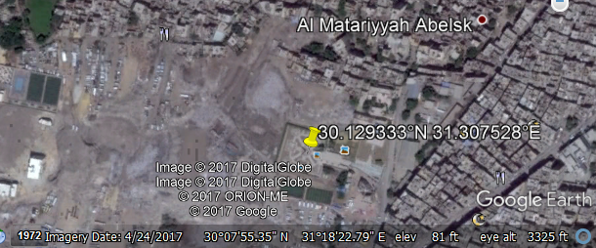

**Cultural Affiliation:** New Kingdom

**Medium:** Blue faience

**Dimensions: 162.71 mm; 6.406 in  
Weight: 131 gm; 4.5 oz**

**Provenance: Old European Collection**

**Condition:** Original

**Discussion:** Ushabtis are anthropomorphic figurines representing servants of the élite deceased in the Hereafter and were placed with them in their internments. The Amduat [underworld] included irrigated tracts of land that were mythically granted to the deceased by the Sun God, Ra, which the Ushabti servant workers would act as agricultural workers in the fields or as fishermen or in many other labor intensive tasks. Nobles and royalty felt that the more Ushabtis they were interred with they would be spared manual labor in the Hereafter. Thus, what began as grave sites with few and larger sized Ushabtis gradually expanded into proliferations of smaller Ushabtis, as patrons developed an anxiety about doing menial labor in the Hereafter. Hieroglyphs on these Ushabtis usually alluded to the opening phrases of Chapter 6 of the *Book of the Dead*: “Greetings - Ushabti. If Osiris [the deceased’s name inserted] be decreed to do any work in Khert-Neter [Hereafter], let any impediment be removed. Here I am [to do the work for him].”

**References:**

Aubert, J.-F. et L. Aubert. 1974. *Statuettes Egyptiennes: Chaouabtis, Ouchebtis.* Paris, 1974.

Janes, Glenn. 2002. *Shabtis. A Private View, Ancient Egyptian Funerary Statuettes in European Private Collections.* Paris: Cybèle.

Newberry, Percy E. 1930-1957. *Funerary Statuettes and Model Sarcophagi.*  Le Caire: Impr. de l'Institut français d'archéologie orientale.

Schneider, Hans D. 1977. *Shabtis - An Introduction to the History of Ancient Egyptian Funerary Statuettes. With a Catalogue of the Collection of Shabtis in the National Museum of Leiden*. 3 volumes, Leiden: Rijksmuseum van Oudheden Te Leiden.

Schlögl, Hermann and Andreas Brodbeck. 1990. *Ägyptische Totenfiguren aus öffentlichen und privaten Sammlungen der Schweiz.* Orbis Biblicus et Orientalis, Series Archeologica, 7. Göttingen, Vandenhoeck & Ruprecht; Freiburg Schweiz, Universitätsverlag.